TOUBLESHOOTING PRACTICE #2 CS1310 Dr. Redfield
BMI Calculator

Name: Weiss Del Carmen

Instructions:
The output for the program (when working correctly) is shown below. A number of errors have been put into the code. Use the chart below to indicate the errors as you find them. The code (with errors) is shown after the output; however, it would be easiest for you to run the program and make use of the error messages to troubleshoot. There are between 3 and 10 errors. You should be able to reproduce the output below once all the errors have been corrected.

Program: ts2_BMI_Calculator.c

Line # Error

25 Forgot ‘&’ in ‘height’

26 ‘height’ and ‘weight’ flipped in ‘printf’

30 weight * height must be height * height

30 ‘weight * 703’ and ‘height * height’ must be in ()

36-38 ‘if’ should be ‘else if’

40 ‘if’ should be ‘else’ with no (BMI > 30)

34-41 ‘if’ and ‘else if’ should have brackets

Output:
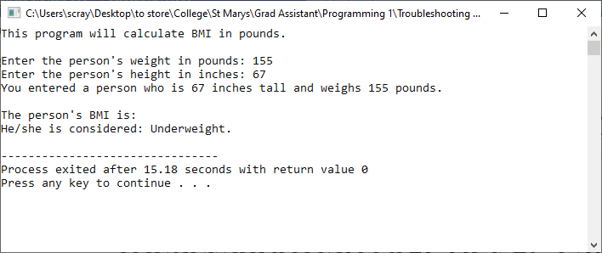

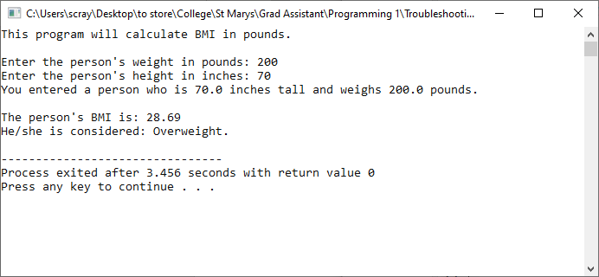

Code:
/* ==========================================================================
Troubleshooting Practice #1
Description: This program calculates a person's Body Mass Index (BMI) in
pounds using the formula:
BMI = ( weightInPounds X 703 ) / (heightInInches^2)

Author: Scott Raymond
Date: 29 Aug 2020
Language: C
For Class: CS1310, Programming I
===========================================================================*/
#include <stdio.h>

void main(void)
{
double weight; /* holds the user's weight in pounds */
double height; /* holds the user's height in inches */
double BMI; /* holds the user's BMI */

printf("This program will calculate BMI in pounds.\n\n");

printf("Enter the person's weight in pounds: ");
scanf("%lf", &weight);
printf("Enter the person's height in inches: ");
scanf("%lf", height);
printf("You entered a person who is %.1lf inches tall and weighs "
"%.1lf pounds.", height, weight);

/* calculate BMI based on formula in description */
BMI = weight * 703 / weight * height;

printf("\n\nThe person's BMI is: %.2lf", BMI);
printf("\nHe/she is considered: ");
if (BMI < 18.5); /* if the person is underweight */
printf("Underweight.\n");
if (BMI >= 18.5 && BMI <= 24.9) /* if the person is normal */
printf("Normal.\n");
if (BMI >= 25 && BMI <= 29.9) /* if the person is overweight */
printf("Overweight.\n");
if (BMI > 30) /* if the person is obese */
printf("Obese.\n");
}

